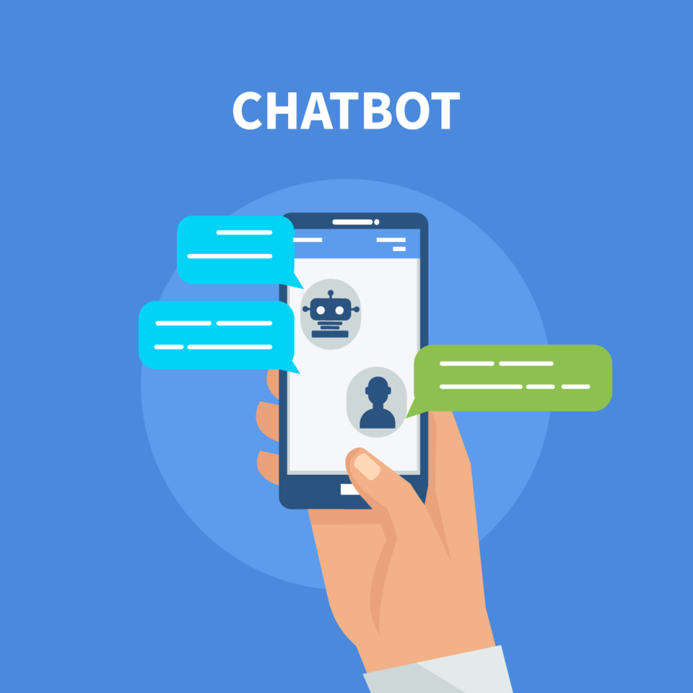

Airbnb Recommendation Bot

User guide on how to set up the project and use the app

Tommy Yong, Prem Chandran, Lim Li Wei | NUS-ISS - Intelligent Process Automation | 01 May 2020

# Setting up the project

Please ensure you have the following ready before proceeding with the instructions.

* You are using python 3.6 or higher
* Telegram app has been installed on your android or iOS smartphone.
* You have a registered account on <https://dialogflow.com/>

Once you have installed python, open a command prompt and CD to the project root folder(“<filepath>/<project name>”).



1. Create a python env. Once created, you should see an ‘env’ folder in your project’s folder

Use "python3 -m venv env" OR use "python -m venv env"

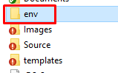

1. Activate the python env. Once activated, you should see (env) next to your command line.

*For Mac*: "source env/bin/activate"

*For Windows*: "env\Scripts\activate"



1. Enter "pip install -r requirements.txt" OR "pip3 install -r requirements.txt". This will install all the required dependencies.
2. Once installation is complete, type in " flask run" and press enter. This will deploy your server locally on your pc.



1. You need to open a channel to your computer so that dialogflow and the telegram bot can communicate with your server. To do this, we will use ngrok. With a new command prompt/terminal CD to the project root folder "<your-file-path>/ISA-IPA-2020-03-21-IS01PT-GRP-Etika-AirbnbAgent". There will be an "ngrok_win" and an "ngrok_mac" file. Rename the file with your OS in use to just "ngrok"(*figure 5.1*). E.g If you are using Windows, delete the "_win" from "ngrok_win". Then from your command prompt, enter "ngrok http localhost:5000". Take note of the https link, it should look something like this <https://f34bb6f6.ngrok.io> (*figure 5.2*).

 

*Figure 5.1 Renaming of ngrok file*



*Figure 5.2 HTTPS link*

1. Go to https://dialogflow.cloud.google.com/ and log in with your account. Proceed to import the dialogflow agent(IPA-AIRBNB.zip) on dialogflow. To do this, first create a new agent and give it a name e.g. "AIRBNB AGENT"(*figure 6.1*). Once created click on the settings gear icon next the agent name and click the “Export & Import” tab(*figure 6.2*). Click “Import From Zip” and select the IPA-AGENT zip file(*figure 6.3*). Type “IMPORT” into the text box and click “IMPORT” (*figure 6.4*).

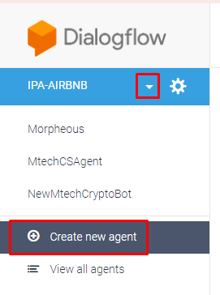

*Figure 6.1 Create new agent*

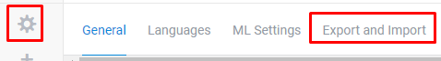

*Figure 6.2 Import options*

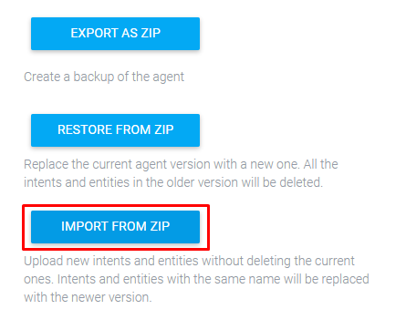

*Figure 6.3 Import from zip*

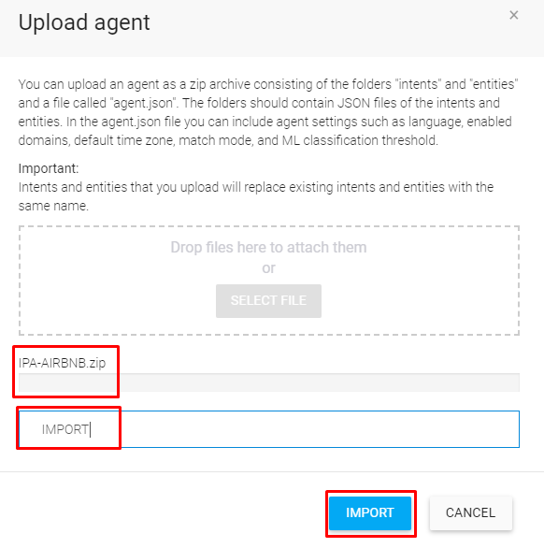

*Figure 6.4 Upload options*

1. Once the agent has been imported and training is done, click on the "Fulfillment" option on the left menu bar(*figure 7.1*). Enable the webhook(If it is not enabled), and copy and paste the ngrok https link on the URL field. Add in "/get_recommendations" right at the end of the ngrok link(*figure 7.2*). Scroll to the bottom and click save. Give it some time to save your settings.

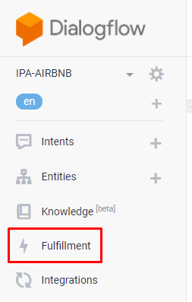

*Figure 7.1 Fulfillment option*

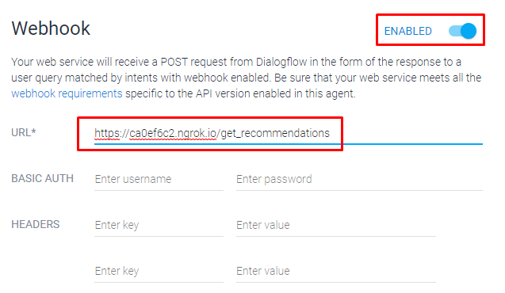

*Figure 7.2 Enable and setting webhook*

1. Set up the link between telegram and dialogflow. From dialogflow, click Integrations(*figure 8.1*). Then, check the Telegram box(*figure 8.2*). A pop-up will appear, enter the bot_token key and click start(*figure 8.3*). This will integrate the bot and dialogflow together.

*Bot Token key*: 1080638501:AAHhksiyyTfavxdcr8SXPZWFQpmV2Hx2mK0

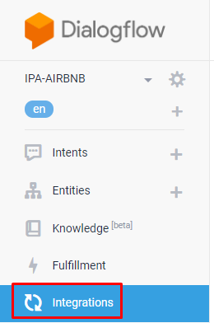

*Figure 8.1 Integrations option*

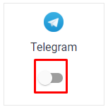

*Figure 8.2 Telegram option*

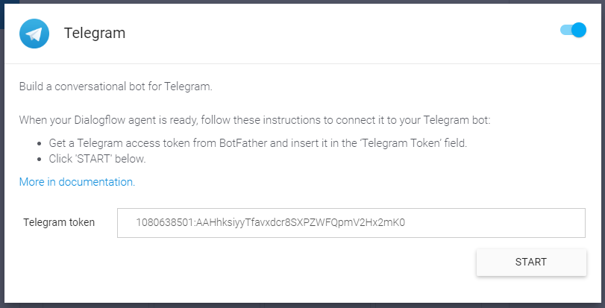

*Figure 8.3 Telegram option*

1. Now open up your telegram app from the smartphone. From the search bar of your chat page, type "IPAAIRBNBBot" click on “IPA-AIRBNB-BOT”. A chat window will be created with the bot, click 'Start'. You can now test sending some search queries such as "Can you find some recommendations for 2 adults, 1 child and 1 infant to stay in Vienna from 5th June to 17th June?". Alternatively, you can open the conversation with “Can you find me some recommendations” and the chatbot will proceed to ask you necessary questions before searching on Airbnb for your recommendations.

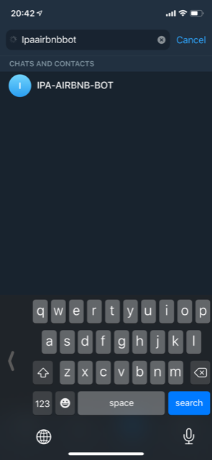 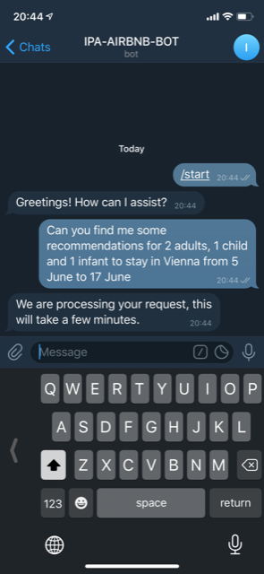

You can also test dialogs from the google assistant via the dialogflow website located on the right side of the screen.

